Abstract Submission Guidelines

- Only students are permitted to present in this poster session.

- Deadline is September 30th, 2016.

- One-page abstract of A4 sheet with four margins of 25.4 mm (1 inch) each.

- Include title, authors, affiliations, pictures and abstract.

- Use Times font, and use the Symbol font for Scientific symbols and Greek letters (alpha, beta, gamma, etc.).

- Title (14-point, bold, Initial Letters of Each Word in CAPITALS, single space, centered) should be followed by one blank line.

- Author list (12-point, single space, centered) should be followed by one blank line. Underline paper presenter’s name in the list of authors. Use comma and superscript numbers to define each name.

- Affiliations with city and country (12-point, single space, centered) should be followed by one blank line. Use semi-colons and superscript numbers to define each institution.

- Text (12-point, single space, single column, single line spacing).

- Indent the first line of each paragraph.

- Photo of all participants will be printed within the abstract for the purpose of making it easier to identify each other during the conference and also after the conference when you look back.

  - Photo of yourself (clearly showing your face) should be included in the abstract.
  - Place the photo in upper left corner of text: Sized 35mm X 45mm.

- The abstract must be converted to the PDF file format before emailing it to us at hata.ayano@e.mbox.nagoya-u.ac.jp. We will compile received abstracts into a booklet without modification. Abstracts will be printed in black and white.
Title of Your Presentation

Shinsaku Okamura¹ and Takashi Yoshimura^{1, 2}

¹Laboratory of Animal Physiology, Graduate School of Bioagricultural Science, Nagoya University, 464-8601, Japan; ²Institute of Transformative Bio-Molecules (WPI-ITbM), Nagoya University, 464-8601, Japan.

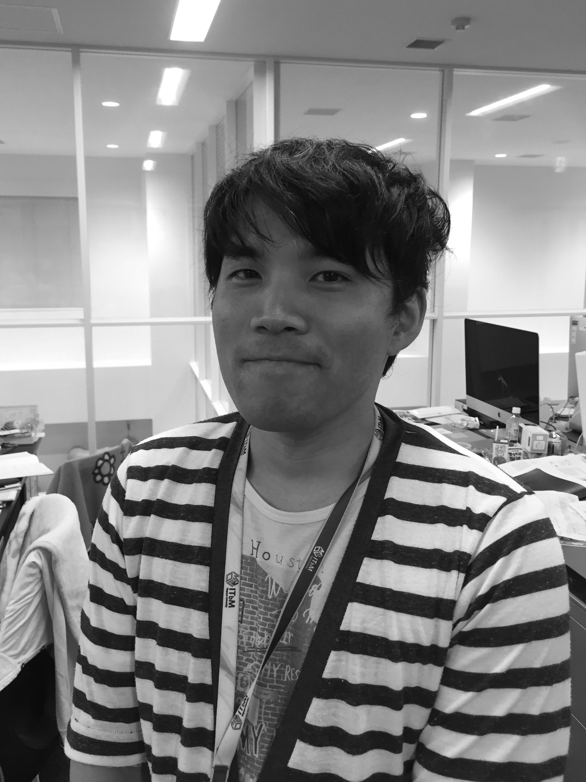
This is just a text sample. This is just a text sample. This is just a text sample. This is just a text sample. This is just a text sample. This is just a text sample. This is just a text sample. This is just a text sample. This is just a text sample. This is just a text sample. This is just a text sample. This is just a text sample. This is just a text sample. This is just a text sample. This is just a text sample. This is just a text sample. This is just a text sample. This is just a text sample. This is just a text sample. This is just a text sample. This is just a text sample. This is just a text sample. This is just a text sample. This is just a text sample. This is just a text sample. This is just a text sample.
This is just a text sample. This is just a text sample. This is just a text sample. This is just a text sample. This is just a text sample. This is just a text sample. This is just a text sample. This is just a text sample. This is just a text sample. This is just a text sample. This is just a text sample. This is just a text sample. This is just a text sample. This is just a text sample. This is just a text sample. This is just a text sample. This is just a text sample. This is just a text sample. This is just a text sample. This is just a text sample. This is just a text sample. This is just a text sample.
This is just a text sample. This is just a text sample. This is just a text sample. This is just a text sample. This is just a text sample. This is just a text sample. This is just a text sample. This is just a text sample. This is just a text sample. This is just a text sample. This is just a text sample. This is just a text sample. This is just a text sample. This is just a text sample. This is just a text sample. This is just a text sample. This is just a text sample. This is just a text sample. This is just a text sample. This is just a text sample. This is just a text sample. This is just a text sample.

References:
1. A. Ardestani et al., (2014) Nature Medicine. 20, 385-397
2. T. Bock et al., (2003) Diabetes. 52, 1716-1722

